**Requirement Engineering**

**Main Source of Requirement Determination**

* Books
* Journals
* People
* Current system documentation
* Website
* Articles

**Requirements Determination**

The new feature or function in the new system is called requirement. There are two main types of requirement determination techniques.

* Traditional
* Modern

**Traditional Techniques**

The main traditional techniques of requirements determination are as follows.

* Interviewing
* Questionnaire
* Group Interview
* Observation
* Studying current system documentation

**Modern Techniques**

* Joint Application Design (JAD)
* Group Support System (GSS)
* Prototype

**Interviewing**

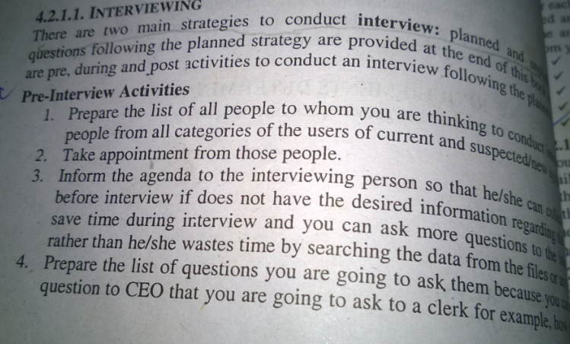

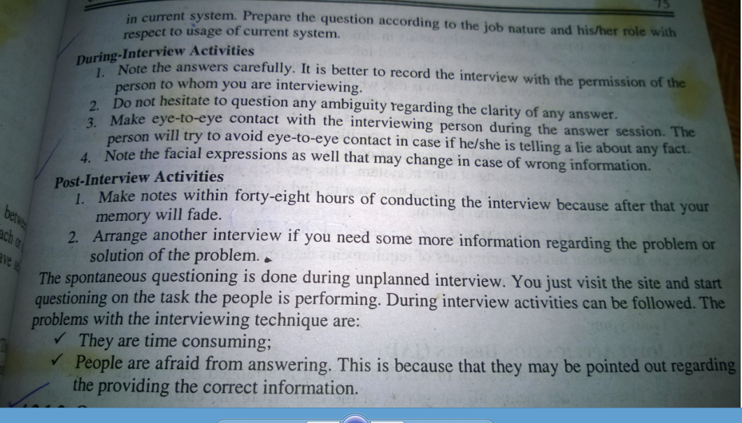

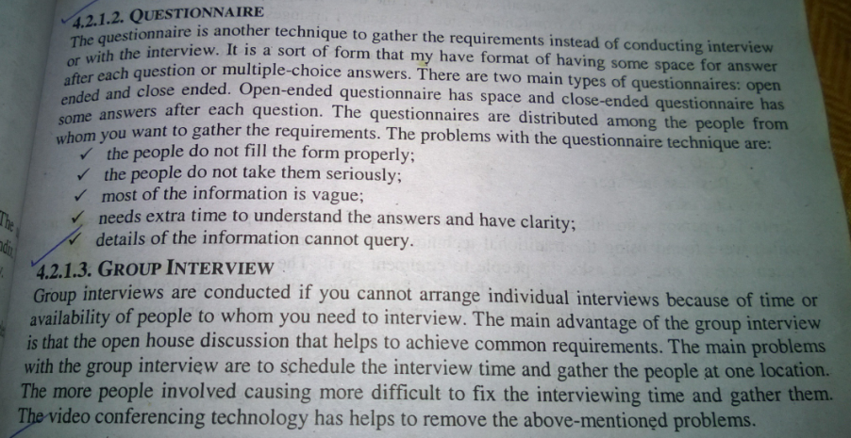

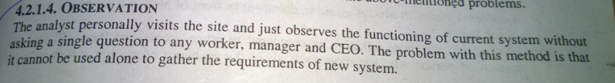

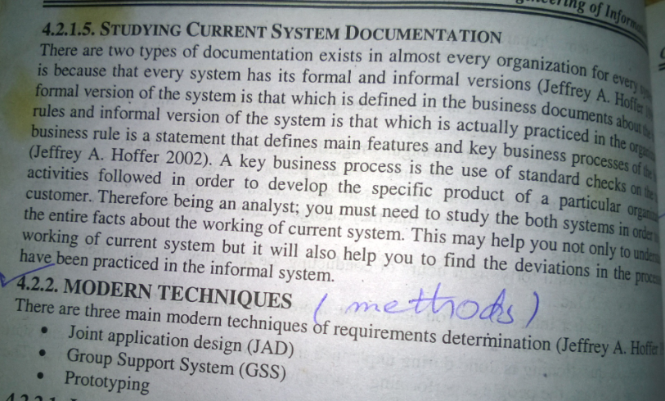

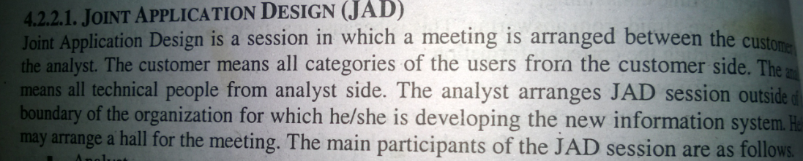

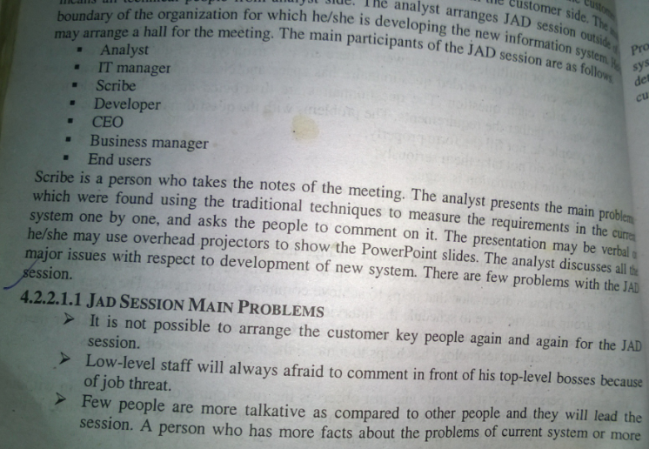

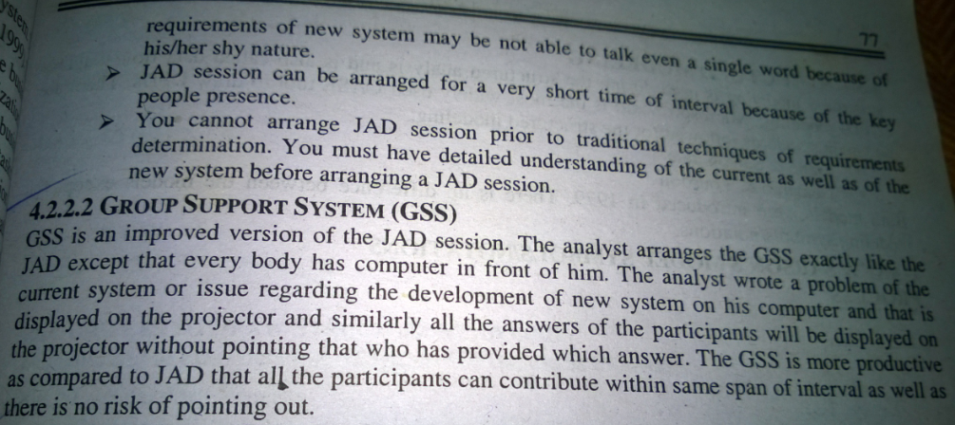

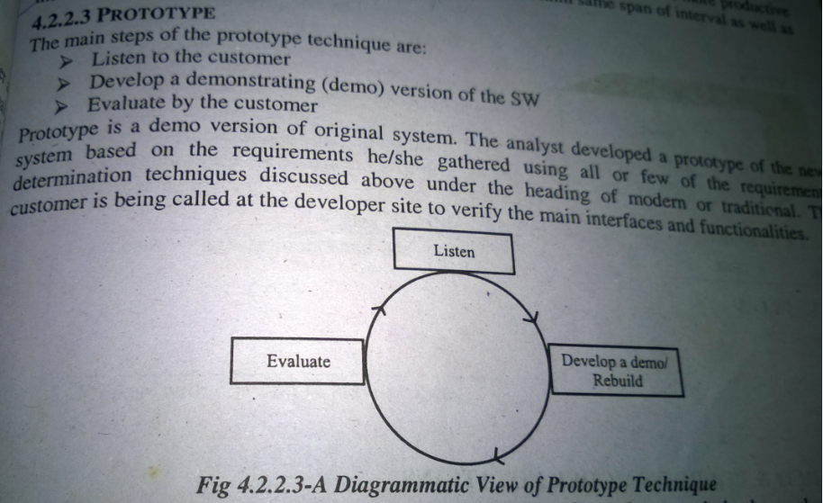

**What is interviewing?**

• Dialogue with user or manager to obtain their requirements

• Two forms:

– Open-ended – conversational, questions with no specific answers in mind

– Closed-ended – structured, questions with limited range of possible answers

Guidelines for Effective

**Interviewing**

• Plan the interview

– Prepare interviewee: appointment, priming questions

– Prepare agenda, checklist, questions

• Listen carefully and take notes (tape record if permitted)

• Review notes within 48 hours

• Be neutral

• Seek diverse views

**Disadvantages of Individual**

Interviews

• Interview one person at a time

• Advantages

– Easier to schedule than group interviews

• Disadvantages

– Contradictions and inconsistencies between interviewees

– Follow-up discussions are time consuming

Interviewing is a common and worthwhile technique used in software requirements gathering. An interview is another form of a meeting, and, in many cases, an e-meeting is a very productive way to conduct the interview. We recommend e-meetings because they can usually be recorded quite easily. GoToMeeting, for example, is a cost-effective meeting service that enables session recording. The interviewer and interviewee can share screens and content, including other application screens, reports, mock-ups and outlines.